Assignment No: 01

Code:

import java.util.Scanner;

public class ArmstrongRange {

    public static void printArmstrongNumber(int start, int end) {

        for (int num = start; num <= end; num++) {

            int originalNum = num;

            int sum = 0;

            int temp = num;

            int digits = 0;

            while (temp > 0) {

                digits++;

                temp /= 10;

            }

            temp = num;

            while (temp > 0) {

                int digit = temp % 10;

                int power = 1;

                for (int i = 0; i < digits; i++) {

                    power \*= digit;

                }

                sum += power;

                temp /= 10;

            }

            if (sum == originalNum) {

                System.out.println(originalNum + " is an Armstrong number.");

            }

        }

    }

    public static void main(String[] args) {

        Scanner scanner = new Scanner(System.in);

        System.out.print("Enter the starting number: ");

        int start = scanner.nextInt();

        System.out.print("Enter the ending number: ");

        int end = scanner.nextInt();

        System.out.println("\nArmstrong numbers between " + start + " and " + end + " are:");

        printArmstrongNumber(start, end);

        scanner.close();

    }

}

Output:

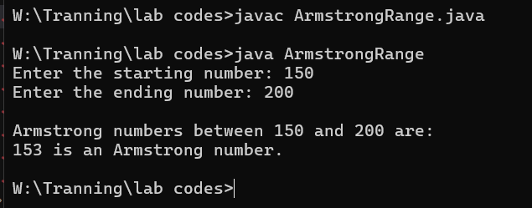

Assignment No: 02

Code:

import java.util.Scanner;

public class grosalcal {

    public static void main(String[] args) {

        Scanner scanner = new Scanner(System.in);

        int choice = -1;

        do {

            System.out.print("Enter basic salary of the employee: ");

            double basicSalary = scanner.nextDouble();

            double hra, da, grossSalary;

            if (basicSalary > 15000) {

                hra = 0.20 \* basicSalary;

                da = 0.60 \* basicSalary;

            } else {

                hra = 3000;

                da = 0.70 \* basicSalary;

            }

            grossSalary = basicSalary + hra + da;

            System.out.println("Gross Salary = " + grossSalary);

            System.out.print("Enter -1 to calculate salary for another employee, or any other number to exit: ");

            choice = scanner.nextInt();

        }

        while (choice == -1);

        System.out.println("Program terminated.");

        scanner.close();

    }

}

Output:

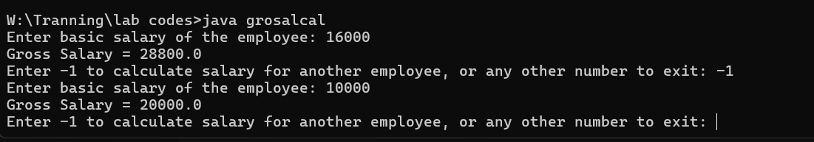

Assignment No: 03

Code:

import java.util.Scanner;

public class evenoddcount {

    public static void main(String[] args) {

        Scanner scanner = new Scanner(System.in);

        int evenCount = 0;

        int oddCount = 0;

        int number;

        while (true) {

            System.out.print("Enter a number (-1 to stop): ");

            number = scanner.nextInt();

            if (number == -1) {

                break;

            }

            if (number % 2 == 0) {

                evenCount++;

            } else {

                oddCount++;

            }

        }

        System.out.println("\nTotal even numbers: " + evenCount);

        System.out.println("Total odd numbers: " + oddCount);

        scanner.close();

    }

}

Output:

